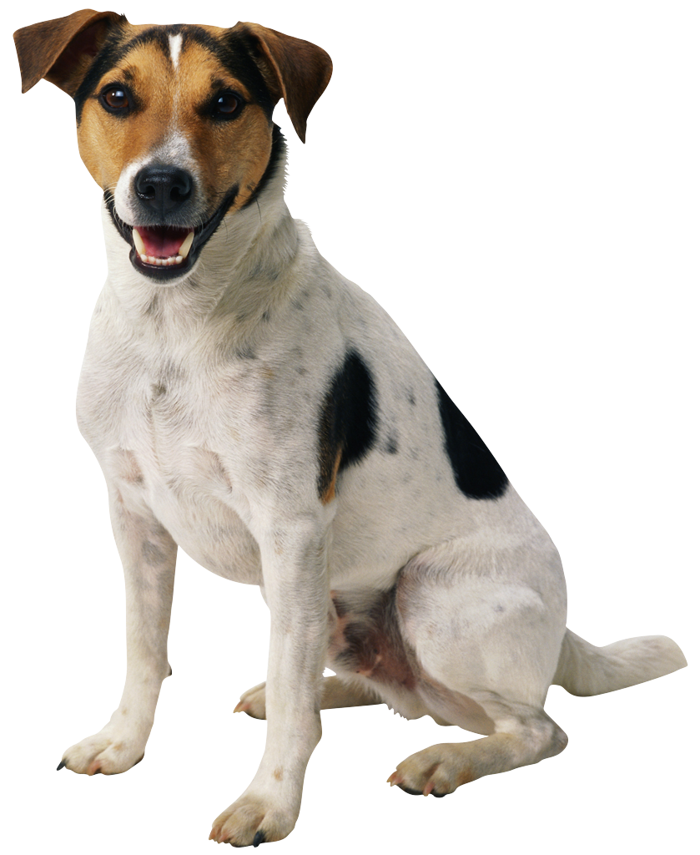
Ms. Albrecht & Mrs. Bunuan, Ms. Barbara, Mrs. Yanick, & Mrs. Juana
Please bring fresh fruit for 33 students for one snack on date list below… (snack suggestions at bottom of page)
PLUS, 1 of the following items for the guinea pigs (bag of celery, cucumbers, bag of spinach, butter lettuce)

AHMED | Idris | 9/22
AZIMAI | Aava | 9/29
BUNDY | Alexandra | 10/6
CALLAHAN | Lucien | 10/13 (day prior we are closed)
CHATTERJEE | Sujoy | 10/20
COOPER | Leo | 10/27
EISCHEN | Anna | 11/3
ELLIS | Clara | 11/10
FUJITA (no English) | Kotetsu | 11/17
GAILES | Soren | 11/24
GAO | Charlotte | 12/1
HIRVONEN | Markus | 12/8
HORN | Sebastian | 12/15
KALLUS | Isabelle | 1/5
KAPOOR | Vidar | 1/12
KISLING | Mia | 1/19 (day prior we are closed)
LACHMAN | Arch | 1/26
LAPE | Warren | 2/2
LENET | Charlie | 2/9
RAAB | Jade | 2/16
RAJESWARAN | Quinn | 2/23
REZAIAN | Justus | 3/02
ROMOFF | Holden | 3/09
SCHOFIELD | Kayden | 3/16
SCHWARTZ | Aria | 3/23
SEJA | Yalda | 3/30 (day prior we are closed)
SEKI | Eveline | 4/6
SHINGLER | Ada | 4/13
SHUBOW | Taylor | 4/20
STEVENSON | Desmond | 4/27
TALAVARI | Leena | 5/4
TOURE | Lina | 5/11
AHMED | Idris | 5/18
AZIMAI | Aava | 5/25
Suggestions: pre-cut fruit tray, pre-cut honey dew or cantalope, whole bananas or apples (12 or more depending on size), clementines (35 if small, 20 if large), pre-washed grapes or berries.

