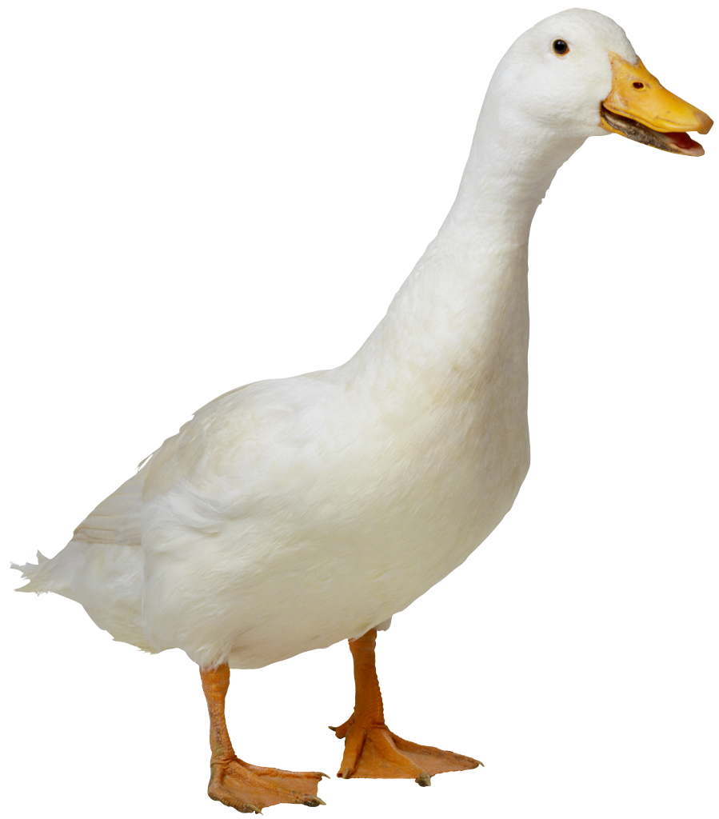
Mrs. Kelsey & Mrs. Jerome Fruit List
Please bring fresh fruit for 26 students for one snack on the Tuesday (unless otherwise noted) list below…

ADELFIO | Teo | 10/3
BREECE | Alex | 10/10
BROWNSTEIN | Seth | 10/17
COHEN | Miles | 10/24
DALY | Freya | 12/1 (WED)
FUJIBAYASHI | Hanae | 11/7
GACHOU | Gemma | 11/14
GLASS | TJ | 11/21
GOONERATNE | Aarya | 11/28
HABERMAN | Julia | 12/5
HANATA | Akari | 12/12
HUGHES | Jonathan | 1/9
MARKEY | Nicholas | 1/16
NAKAMURA | Ibuki | 1/23
NIKOLAEV | Mila | 1/30
RUBEN | Elliot | 2/6
SINGH | Amara | 2/13
VO | Leila | 2/21 (WED)
ADELFIO | Teo | 2/27
BREECE | Alex | 3/5
BROWNSTEIN | Seth | 3/12
COHEN | Miles | 3/19
DALY | Freya | 4/2
FUJIBAYASHI | Hanae | 4/9
GACHOU | Gemma | 4/16
GLASS | TJ | 4/23
GOONERATNE | Aarya | 4/30
HABERMAN | Julia | 5/7
HANATA | Akari | 5/14
HUGHES | Jonathan | 5/21

Suggestions: pre-cut fruit tray, pre-cut honey dew or cantalope, whole bananas (9 or more depending on size), apples (9 or more depending on size), clementines (20 if small, 12 if large), pre-washed grapes or berries.

