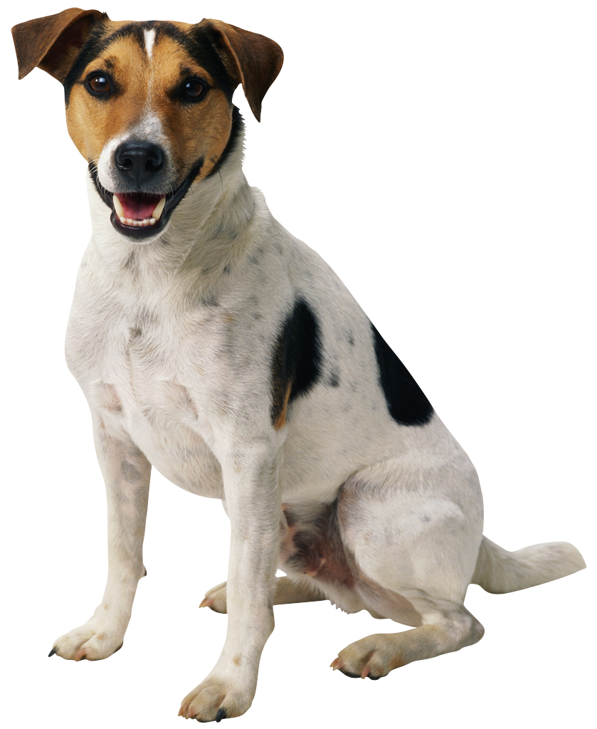
Ms. Albrecht, Ms. Barbara, Mrs. Yanick, & Mrs. Juana
Please bring fresh fruit for 34 students for one snack on date list below… (snack suggestions at bottom of page)
PLUS, 1 of the following items for Mia the guinea pig (red pepper, bag of celery, mini tomatoes, bag of spinach, mini carrots, butter lettuce)

AHMED | Idris | 9/23
AZIMAI | Aryo | 9/30
BARRAUD | Nil | 10/7
BRUNEL | Robin | 10/14
BUNDY | Alexandra | 10/21
CHATTERJEE | Sujoy | 10/28
COOPER | Leo | 11/4
DORAN | Ava | 11/11
ELLIS | Clara | 11/18
FLANNERY | Connor | 11/25
GUEVARA-ROSSEL | Julian | 12/2
HABERMAN | Samuel | 12/9
HORN | Sebastian | 12/16
JACKSON | Bradley | 1/6
KAPOOR | Vidar | 1/13
KISLING | Mia | 1/20
LEVI | Eden | 1/27
LONGENECKER RETANA | Emilia | 2/3
PETKOSKI | Eva | 2/10
RAAB | Jade | 2/18 (WED)
RAJESWARAN | Aldin | 2/24
REZAIAN | Justus | 3/03
ROBERTS | Marc | 3/10
ROMOFF | Mila | 3/17
SABA | Bennett | 3/24
SCHWARTZ | Aria | 4/7
SEBRECHTS | Elodie | 4/14
SEKI | Eveline | 4/21
SHINGLER | Sierra | 4/28
SHINGLER | Ada | 5/5
SHUBOW | Blake | 5/12
SHUBOW | Taylor | 5/19
TOURE | Lina | 5/26
WHITCRAFT | Ellis | 6/2

Suggestions: pre-cut fruit tray, pre-cut honey dew or cantalope, whole bananas (12 or more depending on size), apples (12 or more depending on size), clementines (35 if small, 20 if large), pre-washed grapes or berries.

