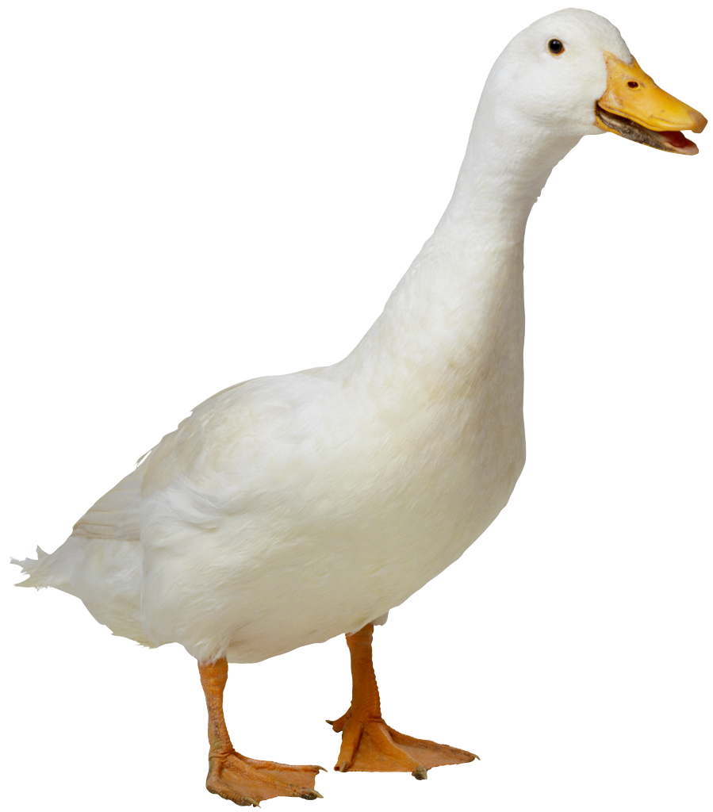
Mrs. Dabrowska, Ms. Anna, Ms. Hortence
Please bring fresh fruit for 26 students for one snack on the Tuesday (unless otherwise noted) list below…
AHMED | Kamil | 10/3
BENSMAN | Noah | 10/10
BRAZAUSKAS | Alice | 10/17
CHUNG | Ruth | 10/24
COLES | Solomon | 11/1 (WED)
DE SILVA | Asher | 11/7
DORAISWAMY | Levi | 11/14
DREYER | Ethan | 11/21
ELIAS | Stan | 11/28
FRIEDLAND | Theodore | 12/5
FUCHIGAMI | Koh | 12/12
GAETA | Leo | 1/9
GILLESPIE | Colin | 1/16
HABIB | Rami | 1/23
KABBAJ | Ryan | 1/30
KASHIPOUR | Sara | 2/6
KHAN | Anya | 2/13
MALAK | Mark | 2/21 (WED)
MAZUR | Abigail | 2/27
MCDONALD | Eleanor | 3/5
MONTEBELLO | Beyorn | 3/12
ÖZMEN | Defne | 3/19
RYCHLIK-PASSETO | MayaBella | 4/2
THOMAS | Elin | 4/9
VERSTRAET | Alena | 4/16
VOGEL | Brody | 4/23
AHMED | Kamil | 4/30
BENSMAN | Noah | 5/7
BRAZAUSKAS | Alice | 5/14
CHUNG | Ruth | 5/21

Suggestions: pre-cut fruit tray, pre-cut honey dew or cantalope, whole bananas (12 or more depending on size), whole apples (12 or more depending on size), whole clementines (30 if small, 15 if large), pre-washed grapes or berries.

